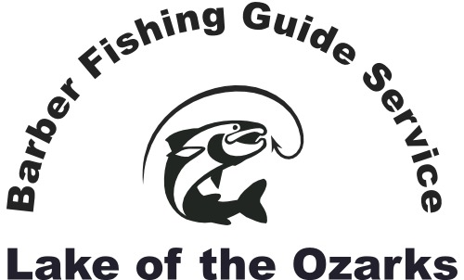

Captain Chris Barber - US Coast Guard Licensed
Guided fishing trips and cruises on beautiful Lake of the Ozarks!
Phone: (314) 583 8174
Email: barberc695@gmail.com
Website: barberfishingguideservice.com

Rates and offerings:
To determine availability and schedule your trip contact us via telephone or the email address provided above. A non-refundable $50 deposit is required to reserve your fishing or cruise trip. If you cancel >14 days prior to your scheduled trip your deposit can be applied to a later date in the same calendar year.

Guided Bass Boat Fishing Trip Rates:
1- 2 anglers, 4-hour trip: $300.00
1-2 anglers, 6-hour trip: $375.00
1- 2 anglers, 8-hour trip: $425.00
3rd angler, add: $ 75.00

Maximum of 3 anglers per bass boat fishing trip. Multi-day and weekly discounts available. Fully loaded, safe, and very comfortable boats.

Guided Pontoon Boat Trip Rates:
Up to 6 anglers, 4-hour trip: $375.00
Up to 6 anglers, 6-hour trip: $450.00
Up to 6 anglers, 8-hour trip: $500.00

Maximum of 6 anglers per pontoon boat trip. Multi-day & weekly discounts available.
Fully loaded, safe, and comfortable pontoon boats with fishing package.

Kayak and Canoe Rentals:
4-hour rental: $50.00 per boat
6-hour rental: $65.00 per boat
8-hour rental: $75.00 per boat

Bass Pro Shop Ascend 128T “sit on” fishing kayaks (1-person fishing kayaks)
We also rent canoes and paddle boats. We provide paddles, life jackets, etc.
Though not “guided trips”, we provide fishing tips and instruction to help you catch fish and have a safe and memorable time on the water. Multi-day and weekly discounts available.

Guided Lake Cruises and Sight Seeing trips:
$100 per hour - Very comfortable pontoon boat

Multi-day and weekly discounts available.

Other Services:
Video: For a nominal fee we will video highlights of your outing and send you an email link, so you can enjoy memories of your trip for years to come.
Water taxi service: If you desire on the water transportation for an event or outing please inquire about rates and availability.
Pick-up service: If your party desires pick up for your fishing trip or cruise at a hotel in Lake Ozark or Osage Beach please inquire about rates and availability.
Gift cards: Gift cards for fishing or cruises are available at the posted rates.
Lodging: Ask us about convenient lodging options.
Guided night fishing: Very few guides offer anglers the opportunity to experience the tremendous crappie and bass bite after dark at Lake Ozark. We’re pleased to offer this option at the posted rates to those who enjoy cooler and calmer fishing conditions on the busy lake.

We accept cash, Pay Pal, and most major credit cards
Barberc695@gmail.com
(314) 583 8174

