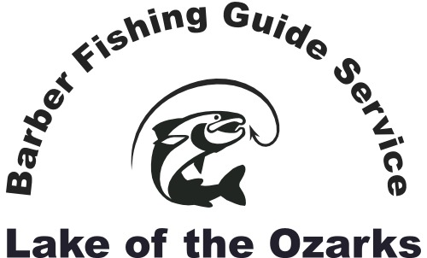

Captain Chris Barber - US Coast Guard Licensed, Insured, Experienced
Guided fishing trips, cruises, and tours on beautiful Lake of the Ozarks!
Phone: (314) 583 8174 Email: barberc695@gmail.com
Website: barberfishingguideservice.com

If spending time on the water or catching fish is on your agenda while visiting Lake of the Ozarks, a member of our team will be pleased to serve you. As experienced boaters and anglers with extensive knowledge and expertise, we routinely guide Lake of the Ozark clients to their preferred fish species and recreational activities. We enjoy teaching and sharing our expertise and guide recreational and professional anglers year-round at the lake.
As our home port and dock is located at the 5-mile marker on the north shore of Lake Ozark, we prefer to guide anglers on the east end of the lake and Gravois arm. We typically begin guided trips at our dock however we will also pick you up on the water anywhere between Bagnell dam and mile marker 15 or any location in the Gravois arm. We will also pick you up at your hotel, lodge, or location outside of the aforementioned lake area for a fee.
We operate fully loaded bass boats that comfortably accommodate up to 3 anglers or fully equipped pontoon boats with fishing packages that accommodate up to 6 anglers. You can utilize your own rods and tackle, or we can provide everything you need for a successful day on the water. As safety is always a priority, each boat is equipped with comfortable Coast Guard approved flotation devices for each angler or passenger. We also provide complimentary non-alcoholic beverages for your trip. All you need is a fishing license, camera, sunscreen, and any snacks you want to consume during the trip.
Crappie fishing is our passion however all our guides also have extensive bass and catfishing knowledge and know where and how to catch them. Bass fishing is usually catch and release however anglers can keep their legal limit of crappie or catfish and if desired your guide will clean and package your catch at our dock.
To determine availability and schedule your trip contact us via telephone or the email address provided above. A $50 deposit is required to reserve your fishing or cruise trip. If you cancel 14 or more days prior to the scheduled trip your deposit can be applied to a later available date in the same calendar year.

Guided Bass Boat Fishing Trip Rates:
1- 2 anglers, 4-hour trip: $300.00
1-2 anglers, 6-hour trip: $375.00
1- 2 anglers, 8-hour trip: $425.00
3rd angler, add: $ 75.00
Maximum of 3 anglers per bass boat fishing trip. Multi-day and weekly discounts available. Fully loaded, safe, and very comfortable boats.

Guided Pontoon Boat Trip Rates:
Up to 6 anglers, 4-hour trip: $375.00
Up to 6 anglers, 6-hour trip: $450.00
Up to 6 anglers, 8-hour trip: $500.00
Maximum of 6 anglers per pontoon boat trip. Multi-day & weekly discounts available.
Fully loaded, safe, and comfortable pontoon boats with fishing package.

Kayak and Canoe Rentals:
4-hour rental: $50.00 per boat
6-hour rental: $65.00 per boat
8-hour rental: $75.00 per boat
Bass Pro Shop Ascend 128T “sit on” fishing kayaks (1-person fishing kayaks)
We also rent canoes and paddle boats. We provide paddles, life jackets, etc.
Though not “guided trips”, we provide fishing tips and instruction to help you catch fish and have a safe and memorable time on the water. Multi-day and weekly discounts available.

Guided Lake Cruises and Sight Seeing trips:
$100 per hour - Very comfortable pontoon boat
Multi-day and weekly discounts available.

Other Services:
Video: For a nominal fee we will video highlights of your outing and send you an email link, so you can enjoy memories of your trip for years to come.
Water taxi service: If you desire on the water transportation for an event or outing please inquire about rates and availability.
Pick-up service: If your party desires pick up for your fishing trip or cruise at a hotel in Lake Ozark or Osage Beach please inquire about rates and availability.
Gift cards: Gift cards for fishing or cruises are available at the posted rates.
Lodging: Ask us about convenient lodging options.
Guided night fishing: Very few guides offer anglers the opportunity to experience the tremendous crappie and bass bite after dark at Lake Ozark. We’re pleased to offer this option at the posted rates to those who enjoy cooler and calmer fishing conditions on the busy lake.

We accept cash, Pay Pal, and credit cards
Barberc695@gmail.com (314) 583 8174

